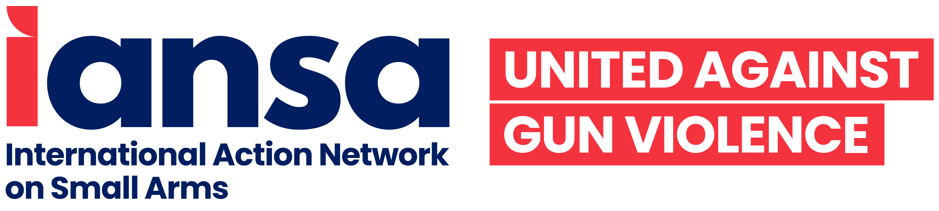

UPDATE #2:
77th Session of the United Nations General Assembly (UNGA) First Committee on Disarmament and International Security

Small Arms and Light Weapons
By Amelie Namuroy, IANSA

During the second week of the First Committee the general debate came to a conclusion. Meanwhile, member states continued to express their grave concerns over the deterioration of peace and international security, caused in part by the unregulated and pervasive availability of small arms and light weapons (SALW) and its ammunition.

Illicit trade of SALW

India, Guatemala, Jordan, Colombia, Honduras, Kenya, Lebanon, Togo, Zambia, Paraguay, the Democratic Republic of the Congo (DRC), Argentina, Tunisia, and Guinea, as well as other states, highlighted the consequences of the widespread availability of SALW. For example, Honduras stated that the illicit proliferation of SALW sustains and exacerbates armed conflicts, violence, crime, and migration. Honduras added that the illicit manufacturing and trafficking of SALW is closely related to issues of sustainable development and gender equity. Similarly, Colombia said that “the illicit trade in SALW and their ammunition continues to be one of the collective threats with the greatest impact due to its humanitarian and socioeconomic consequences” and that the proliferation of these weapons “amplifies pain”.

The Democratic Republic of the Congo (DRC) highlighted that illicit arms trafficking affects the lives of thousands and is one of the root causes of several armed conflicts that happened in the last two decades. Antigua and Barbuda emphasised that countries in the Caribbean region are not manufacturers or significant importers of small arms and ammunition. However, they continue to experience the devastating consequences of the illicit trade of these weapons. In parallel, Jamaica called for greater action from states who manufacture weapons and ammunition to ensure that they do not make their way into illicit use or trade. Guinea highlighted a concrete step it has taken with the establishment of a National Commission on SALW for the period 2018–22.

In that sense, Guinea developed regulations on the marking of homemade firearms, the marking and registration of weapons held by civilians, the identification and listing of local manufacturers, as well as the installation of scanners at the country’s borders.

The diversion of SALW to non-state actors is an issue that several states flagged. While Angola asserted its right to use SALW to ensure selfdefence and answer to other national needs, it recognised that the illicit trade of conventional arms and its ammunition, and in particular their diversion to non-state actors, has profoundly destabilising effects. Argentina on behalf of the Community of Latin American and Caribbean States (CELAC) stated that the diversion of weapons to non-state actors or unauthorised users is often linked to transnational organised crimes. Angola, Romania, and Argentina concurred that the diversion of SALW is a threat to peace, security, and sustainable development.

However, despite emphasising these harmful consequences and challenges, many states also reiterated the importance of complying with and effectively implementing existing instruments to control SALW, including the United Nations Programme of Action to Prevent, Combat and Eradicate the Illicit Trade in Small Arms and Light Weapons in All Its Aspects (UNPoA), the Arms Trade Treaty (ATT), and other regional instruments.
SALW ammunition and Open-Ended Working Group on conventional ammunition (OEWG)

Colombia recognised the need to include ammunition as an inherent part of SALW-related issues. Colombia asserted that ammunition is one of the fundamental aspects of SALW and, as such, among the problems posed by their illicit trade and diversion. Colombia urged that provisions of the UNPoA be applied to ammunition and to strengthen dialogues between member states on this specific matter. Concerning the work of the OEWG, Colombia underlined that it remains essential that the new framework, in order to be comprehensive and fill in existing gaps, should “explicitly and clearly incorporate small arms and light weapons ammunition.” Jamaica reiterated that the gaps in throughlife ammunition management demand urgent action from member states. The DRC, Togo, and India stated that they continue to follow the discussions of the OEWG, while Turkey, Georgia, and Mauritania expressed their support for the work of the group. Paraguay underlined that the outcome document of the Eighth Biennial Meeting of States (BMS8) on the UNPoA will serve as a good basis for discussions during the Fourth Review Conference on the UNPoA in 2024. As such, Paraguay believes that the obligations, and commitments on the issue of conventional ammunition must have a central place in these upcoming discussions.

Civil society statements

On Thursday, 13 October, civil society contributed statements on a range of thematic issues, including on SALW. The International Action Network on Small Arms (IANSA) focused its statement on the following key points:
- Support resolutions containing gendersensitive measures;
- Support language recognising that SALW and their ammunition are inextricably linked, and that ammunition is what gives SALW their deadly power;
- Recognise that the vast majority of deaths and injuries due to SALW occur in situations of violence and crime, not in armed conflict;
- Demonstrate their commitment to the full, equal, meaningful, and effective participation of women in the UNPoA process by, at a minimum, ensuring parity in their delegations’ leadership and composition, as well as their presentations; and,
- Ensure that civil society is able to participate fully in First Committee proceedings by keeping the meetings open.

In order to achieve this desired progress, IANSA called on member states to work in close partnership with civil society organisations, in particular women and underrepresented groups disproportionately affected by gun violence.

At the end of the segment dedicated to civil society statements, no member states responded or asked questions to the civil society representatives that were present.

Exchange with the United Nations High Representative for Disarmament Affairs and conclusion

The week ended with a statement from Ms. Izumi Nakamitsu, High Representative for Disarmament Affairs. The High Representative for Disarmament Affairs reiterated some of the concerns she expressed during her opening remarks to the First Committee and concluded by underlining the important role played by civil society and the support they offer to states in a myriad of ways as advocates, researchers and experts. She called “on every Member State to strengthen the principles of transparency and inclusivity of relevant non-governmental actors, [including private sector and industry actors, as well as young people] to support the work of intergovernmental disarmament processes.” Ms. Nakamitsu also highlighted the fact that new progressive language on gender was included in the BMS8 outcome document. However, during BMS8, civil society was excluded from large portions of the meeting significantly diminishing the possibility for all voices to be heard, especially the voices of civil society representatives from communities most affected by gun violence. It also prevented civil society representatives to be present in the conference room when key language on gender—despite the overall progress made on the topic—was deleted from the outcome document.
Discussions on SALW will resume later on next week and the First Committee will move forward to take action on draft resolutions.

