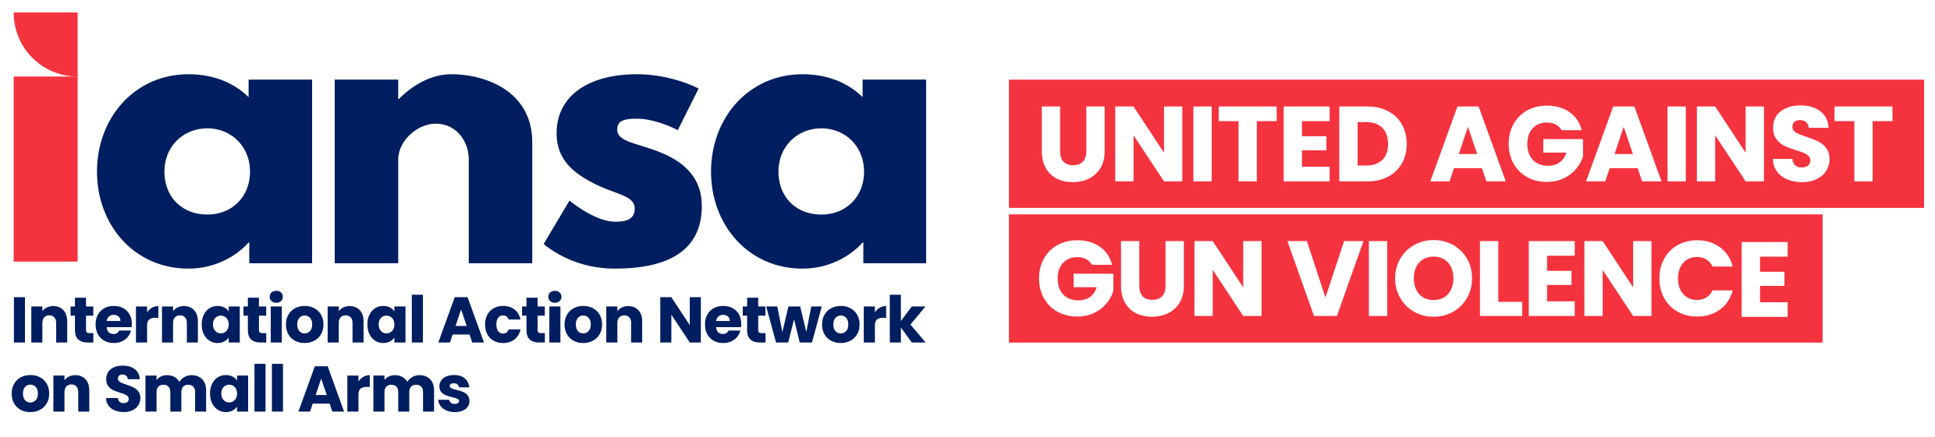

UPDATE #1:
77th Session of the United Nations General Assembly (UNGA) First Committee on Disarmament and International Security

Small Arms and Light Weapons
By Amelie Namuroy, IANSA

During the first week of the 2022 First Committee of the UN General Assembly on Disarmament and International Security, delegations made opening remarks on the threats posed by small arms and light weapons (SALW). They also expressed concerns about the negative impacts caused by the proliferation and illicit trade of SALW, namely, threatening international peace and security, hindering social and economic development, perpetuating fear and crimes, fuelling gender-based violence, and undermining human rights.
Member states largely commended the successful adoption by consensus of the outcome document of the Eighth Biennial Meeting of States (BMS8) on the UN Programme of Action on the illicit trade in small arms and light weapons (UNPoA) held from 27 June to 1 July 2022. Ghana, the Philippines, Yemen, Nepal, Iraq, Indonesia, Bangladesh, Egypt, and Côte d’Ivoire were among the states that welcomed the progress made during BMS8.
On the other hand, Peru argued that little to no progress was made during the meeting, citing the non-inclusion of stricter regulation on ammunition in the outcome document and underlining that, in practical terms, excluding key language on ammunition in the only mechanism on SALW was a step backwards. In parallel, France stated its intention to continue being involved in the work of ammunition, which “is of particular importance for security, the fight against trafficking, but also for the safety of populations.” Uruguay stressed the scant progress made in relation to the Seventh Biennial Meeting of States that took place just a year prior. Sri Lanka noted that it hoped the commitments made during the meeting will contribute to establishing a normative framework for small arms control.
Other delegations, such as Nepal, Ethiopia, Tajikistan, Libya, Gabon, Nigeria, Israel, and Trinidad and Tobago, recognised the significance of the UNPoA as an essential instrument in combating the illicit trade in SALW. The need for international cooperation and assistance as an integral part of the successful implementation of the UNPoA was also noted by the Sistema de la Integración Centroamericana (SICA), while Uruguay emphasised the need for international assistance and cooperation for states that requested it in order to reduce the technological gap for the security of SALW stockpiles and to prevent their diversion.
The threats posed by SALW to security and sustainable development remain a major concern to member states. For example, the Caribbean Community (CARICOM) stated that the damage done by gun violence to the human community and to resources “is an immediate and profound threat to the security and stability of the Member States of CARICOM,” underlining that this violence is counter to the will of CARICOM’s states to implement the 2030 Agenda for Sustainable Development. The Nordic countries mentioned that the illicit flows of SALW constitute a key challenge to international peace, security and development. Nepal, Bangladesh, and Canada also said that SALW constitute a risk to international security.
On the other hand, the Association of Southeast Asian Nations (ASEAN) asserted the legitimate right and authority of sovereign nations to use conventional weapons to maintain national security and to defend territorial integrity, while underlining the need to address the growing illicit proliferation of conventional weapons, which impedes economic and social progress and threatens peace and security. Amid shrinking civil space for non-governmental organisations representatives, Canada and Kyrgyzstan emphasised the important role played by civil society actors in the fight against SALW proliferation. Canada emphasised its continued engagement with civil society, while underscoring that many civil society organisations are present in New York City to participate in the First Committee and have been seeking progress and answers on disarmament issues for years. CARICOM underlined the vital and insightful role that civil society continues to play in the field of disarmament and international security and acknowledged their unique perspective and contribution.
South Africa, Colombia, and Japan will introduce their annual draft resolution on SALW entitled: “The Illicit Trade in Small Arms and Light Weapons in All Its Aspects”. Following previous practice, the draft resolution will build on existing commitments and contain certain key recent developments and conference outcomes.

